Medical file

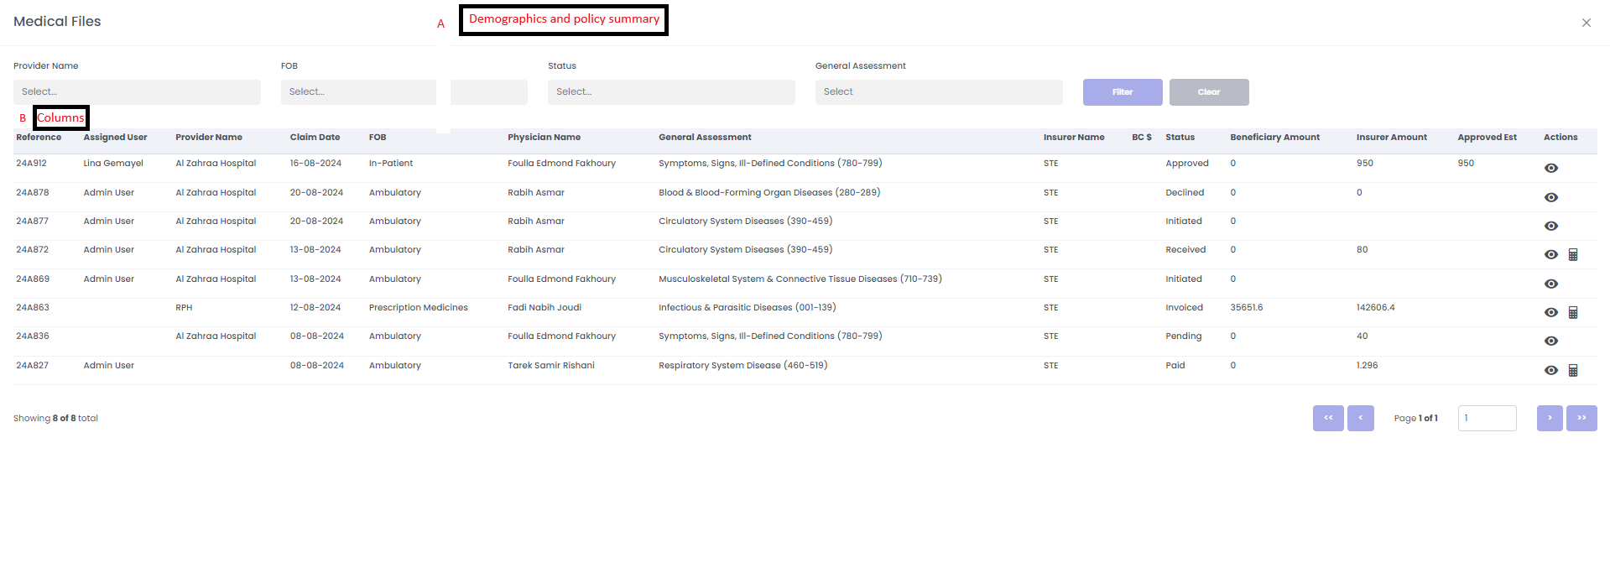
A-Demographics Included
- Patient Name
- DMP/Blacklist Status

B-Need to adjust the following columns:
- Remove Assigned User and insurer name
- To add Requested claim date/ report date, Admission claim date, discharge date
- To Add ICD code with description
- Replace name of Beneficiary Amount mentioned on medical file to be beneficiary copay as mentioned on claim initial page
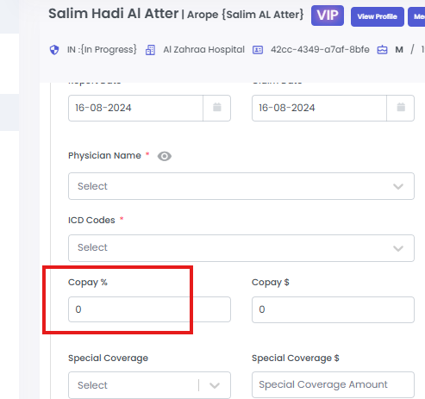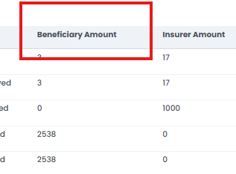
- What is the difference between Insurer Amount and Approved Est in medical file?
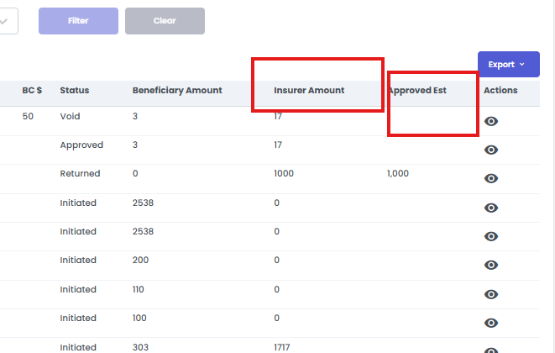
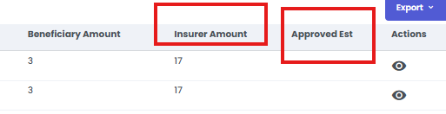

6-Estimation cost To notify the nominations between the medical file and the initial screen

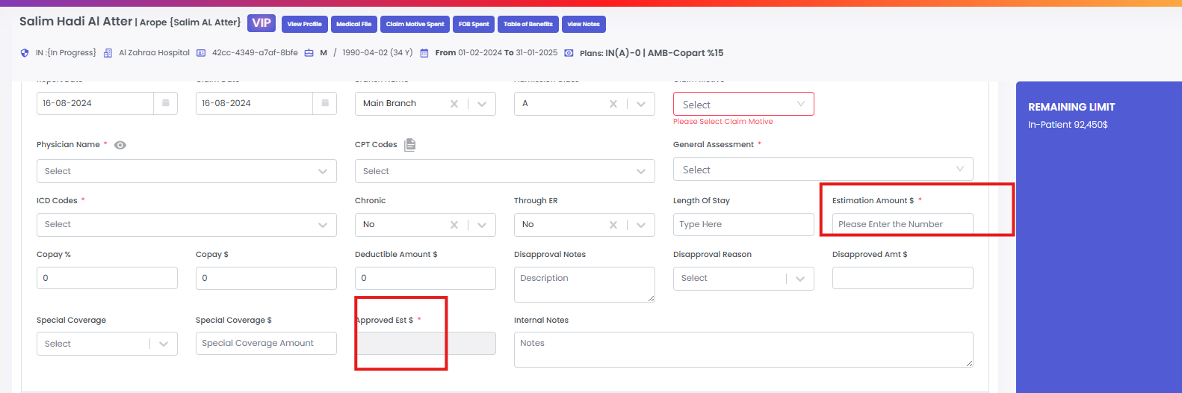

7-Add Approval Notes, Internal Notes, Medical Notes, and Processing Notes. These should be implanted in the form of a button/hyperlink that, upon being pressed, open the contents as a splash screen without taking the use to another page

8-Physician name with specialty

9-check void if its un used

